2019 COMPETITION LICENCES.

APPLICATION INSTRUCTIONS.

Applying for a new or renewing an FIA, FIM or CIK Competition Licence.

As we approach the end of the year we will be accepting new Licence applications and renewals for 2019 from DECEMBER 1st 2018. The Licencing department will be closed from Dec 21st till the New Year, so it is highly recommended that you apply early.

Process time in January is 4 working days.

For 2019, and as in previous years, we will NOT be accepting or processing Licence applications on the day of an event. It is you’re responsibility to ensure you have allowed sufficient time to have your Licence processed in advance.

These are the procedures.

LOCATION

All Licences are produced at the Dubai Office. Applications may be submitted to our Abu Dhabi Office and must be complete and with Payment. Applications received from our Abu Dhabi office will be returned to Abu Dhabi and will take 2 weeks as a minimum to process.

WEBSITE

Application forms and competition Licence notes plus other details can be downloaded from our website https://www.atcuae.ae/competitors-forms/

LICENCE COURSES

If you are a new licence holder and are applying for the following Licences you will be required to attend and pass an accredited Licensing course.

FIA – Race National (Circuit) CIK – Kart National (Circuit) FIM – National Road Race. (Circuit)

For further details about these courses please contact licence@atcuae.ae or call 04 296 1122.

MEDICAL

1) All International Licence holders must have an annual medical, and pass a one time “FIA Race True” online diploma.

2) Medicals for All Senior National Licence holders are valid for 3 years. Please check that yours is valid.

3) Competitors over 45 years (FIA) applying or renewing a Circuit or Kart Licence must have an annual medical. Competitors over 55 years (FIM) applying or renewing a Circuit Licence must have an annual eyesight report.

4) A Medical can be done at any clinic or Medical centre and must be stamped.

5) Competitors under 18 years and applying for a Kart Licence do not require a medical.

6) Competitors over 15 years and applying for the first time for a Race National Licence will require a medical.

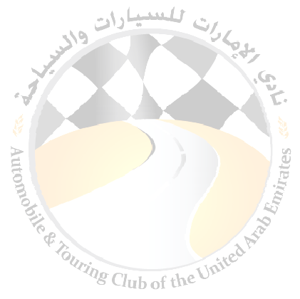

PERSONAL ACCIDENT INSURANCE

All ATCUAE Valid Competition holders are covered by our Personal accident Insurance. This only applies to official events that have been sanctioned by the ATCUAE. Private testing prior to an event is NOT covered and we recommend that you take out an additional Policy.

WALK IN APPLICATIONS

Applications can be received in person at our Office in Dubai, and as mentioned above must have all the correct details. All paperwork must be Original, and incomplete applications will not be processed.

PAYMENT AND FEES

All payments must be made in CASH. No Cheques or Credit Cards will be accepted.

NON OBJECTION LETTERS- FIA/CIK/FIM – VERY IMPORTANT

If your Nationality is not Emirati then “we” will need to apply to your home country for a letter of non-objection for you to hold a UAE Competition Licence. This is a standard procedure and is part of the International Sporting Code. Even if you are renewing your Licence we will need to acquire this letter as it is done yearly.

PROOF OF EDUCATION

If you are applying / reapplying for a CIK Kart licence and you are under 18 years, you must provide proof that you are in fulltime education. Exceptional and bona fide cases may be considered on a case by case basis.

